Задача 7. Найти производную.
7.1. 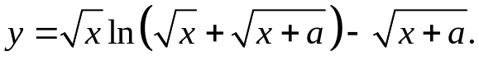
√x + √x
y'= ln(√x+√(x+a)) + 2√x 2√(x+a) _ 1 =
2√x √x+√(x+a) 2√(x+a)
= ln(√x+√(x+a)) + √x .
2√x 2(√x+√(x+a))√(x+a)
7.2. 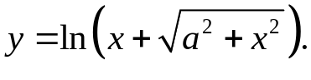
y'= 1+x/√(a²+x²) = x+√(a²+x²) = 1 .
x+√(a²+x²) (x+√(a²+x²))√(a²+x²) √(a²+x²)
7.3. 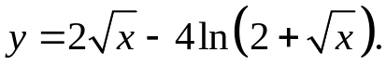
y'= 1 _ 2/√x = 2+√x-2 = 1 .
√x 2+√x √x(2+√x) 2+√x
7.4. 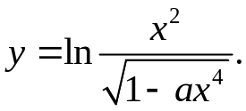
y'= √(1-ax⁴) * 2x√(1-ax⁴)+2ax⁵/√(1-ax⁴) = 2√(1-ax⁴)+2ax⁴
x² 1-ax⁴ x-ax⁵
7.5. 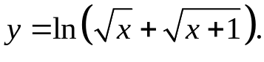
1 + 1 _
y'= 2√x 2√(x+1) = √(x+1)+√x = 1 .
√x+√(x+1) 2√(x²+x)( √x+√(x+1)) 2√(x²+x)
7.6. 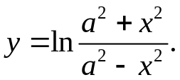
y'= a²-x² * 2x(a²-x²)+2x(a²+x²) = 4xa²
a²+x² (a²-x²)² a⁴-x⁴
7.7. 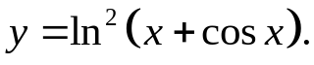
y'= 2ln(x+cosx)* 1-sinx .
x+cosx
7.8. 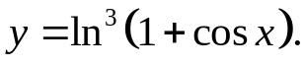
y'= -3ln²(1+cosx)* -sinx .
1+cosx
7.9. 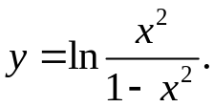
y'= 1-x² * 2x(1-x²)+2x³ = 2 .
x² (1-x²)² x(1-x²)
7.10. 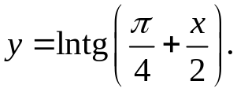
y'= ctg(π/4+x/2) = 2 = 2 .
2cos²(π/4+x/2) sin(π/2+x) cosx
7.11. 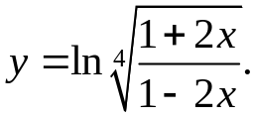
y'= 1-2x * 2(1-2x)+2(1+2x) = 1 .
4+8x (1-2x)² 2-8x²
7.12. 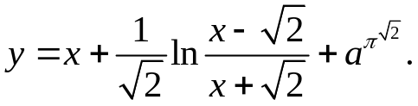
_
y'= 1+ (x+√2)(x+√2-x+√2) = 1+ 1 .
(x-√2)(x+√2)² x²-2
7.13. 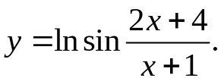
y'= cos((2x+4)/(x+1)) * 2x+2-2x-4 = -2ctg((2x+4)/(x+1))
sin((2x+4)/(x+1)) (x+1)² (x+1)²
7.14. 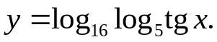
y'= 1 * 1 * 1 = 1 = lntgx _
ln16*log₅tgx tgx*ln5 cos²x ln4*ln5*sin2x*log₅tgx 2sin2x*ln³2
7.15. 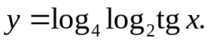
y'= 1 = lntgx .
4ln²2*cos²x*tgx*log₂tgx 2sin2x*ln³2
7.16. 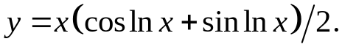
y'= 1/2*(coslnx+sinlnx+x(-1/x*sinlnx+1/x*coslnx))= coslnx
7.17. 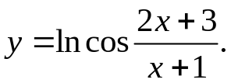
y'= -sin((2x+3)/(x+1))*2x+2-2x-3 = ctg((2x+3)/(x+1))
cos((2x+3)/(x+1)) (x+1)² (x+1)²
7.18. 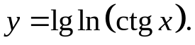
y'= -lge = -2lge .
lnctgx*ctgx*sin²x lnctgx*sin2x
7.19. 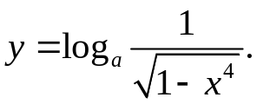
y'= 4x³ = 2x^{3 .}
2(1-x⁴)lna lna(1-x⁴)
7.20. 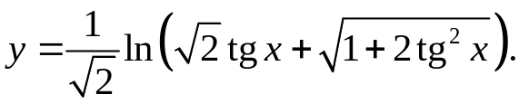
1 * 4tgx _
y'= cos²x 2√2cos²x√1+2tg²x = 2tgx _
√2tgx+√(1+2tg²x) cos⁴x√(1+2tg²x)( √2tgx+√(1+2tg²x))
7.21. 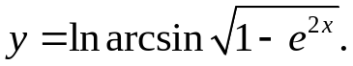
y'= 1 * 1 * -2e^{2x} = -e^{x} _
arcsin√(1-e^{2x}) √(1-1+e^{2x}) 2√(1-e^{2x}) √(1-e^{2x})arcsin√(1-e^{2x})
7.22. 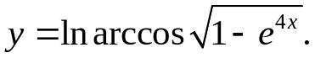
y'= 1 * 1 * -4e^{4x} = -2e^{2x} _
arccos√(1-e^{4x}) √(1-1+e^{4x}) 2√(1-e^{4x}) √(1-e^{4x})arccos√(1-e^{4x})

7.23. 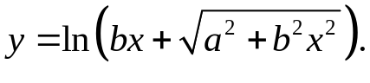
y'= b+b²x/√(a²+b²x²) = b _
bx+√(a²+b²x²) √(a²+b²x²)
7.24. 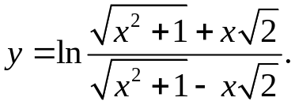
y'= √(x²+1)-x√2 * (x/√(x²+1)+√2)( √(x²+1)-x√2)-(x/√(x²+1)-√2)( √(x²+1)+x√2)=
√(x²+1)+x√2 (√(x²+1)-x√2)²
= (x+√(x²+1))(√(x²+1)-x√2)-(x-√2√(x²+1))(√(x²+1)+x√2) =
√(x²+1)(√(x²+1)-x√2)²
= 2√2 _
√(x²+1)(√(x²+1)-x√2)²
7.25. 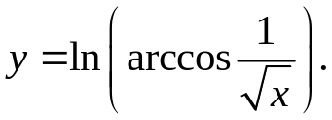
y'= -1/(2√x³) = -1 _
arcos(1/√x) 2√x³arccos(1/√x)
7.26. 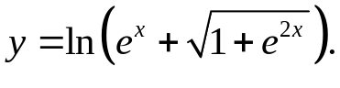
y'= e^{x}+e^{2x}/√(1+e^{2x}) = e^{x} _
e^{x}+√(1+e^{2x}) √(1+e^{2x})
7.27. 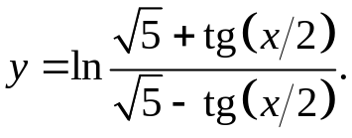
√5-tg(x/2)+√5+tg(x/2)
y'= √5-tg(x/2) * 2cos²(x/2) 2cos²(x/2) = √5 _
√5+tg(x/2) (√5-tg(x/2))² (5-tg²(x/2))cos²(x/2)
7.28. 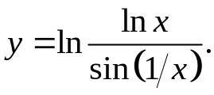
sin(1/x)+lnxcos(1/x)
y'= sin(1/x)* x x² = 1 + ctg(1/x)
lnx sin²(1/x) xlnx x²
7.29. 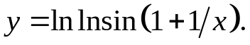

y'= cos(1+1/x) * -1/x² = -ctg(1+1/x) _
lnsin(1+1/x) sin(1+1/x) x²lnsin(1+1/x)
7.30. 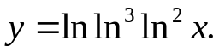
y'= 3ln²ln²x*3ln²x*1 = 6 _
ln³ln³x ln³x x xlnln²xlnx
7.31. 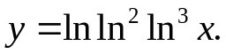
y'= 2lnln³x*3ln²x* 1 = 6 _
ln²ln³x ln³x x xlnln³xlnx

